1.

2.

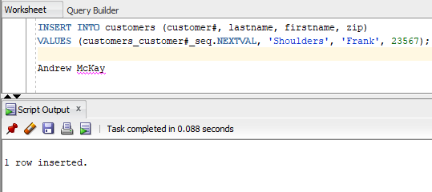

3.

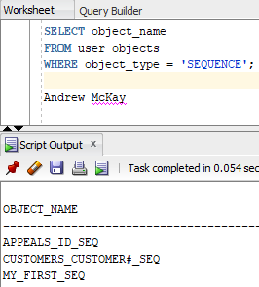

4.

5.

9.

Andrew McKay

IT-314-002